**BIO FOR STEVE AMBROSO**

My grandparents moved to the US in the 1920’s from Calvene, Italy. Calvene is in the Veneto region of Northern Italy, an hour west of Venice. I have always been fascinated by my Italian heritage, and have visited the country a total of eight times. My favorite part of the visit is always spending time with relatives who still live in this small town near the Dolomite Mountains.

It has been an honor to carry over that Italian pride to the Sun Lakes Italian-American Club. My wife Connie and I joined the SLIAC after taking full time retirement in late 2017 and moving to Palo Verde from the Dallas area. I became president of the club 4 years ago in the midst of the Covid epidemic, when the future of the club was in doubt. Meetings were canceled due to Covid, and paid membership dropped to the 50’s. It was a slow process to get monthly dinner meetings from 30 members in the tiny Saguaro Room to an average of 110 members in the Oakwood Ballroom. Currently we have 168 paid members in the club.

With the help of an active board of directors and committee helpers, and some very interesting monthly topics and speakers (Italian Trivia / Italian wine talk / Local Italian Restaurant survey / The Great Italian Bake-Off Contest / Queen Creek Olive Mill tour / Sisk Park Potluck & Bocceball tournament/ Traditional Italian Wedding Night Event / Annual Holiday Party), the Sun Lakes Italian-American Club is the envy of every other club in Sun Lakes.

I am running for President of the SLIAC again, to continue to make this club the best it can be.

Grazie mille!

Steve Ambroso

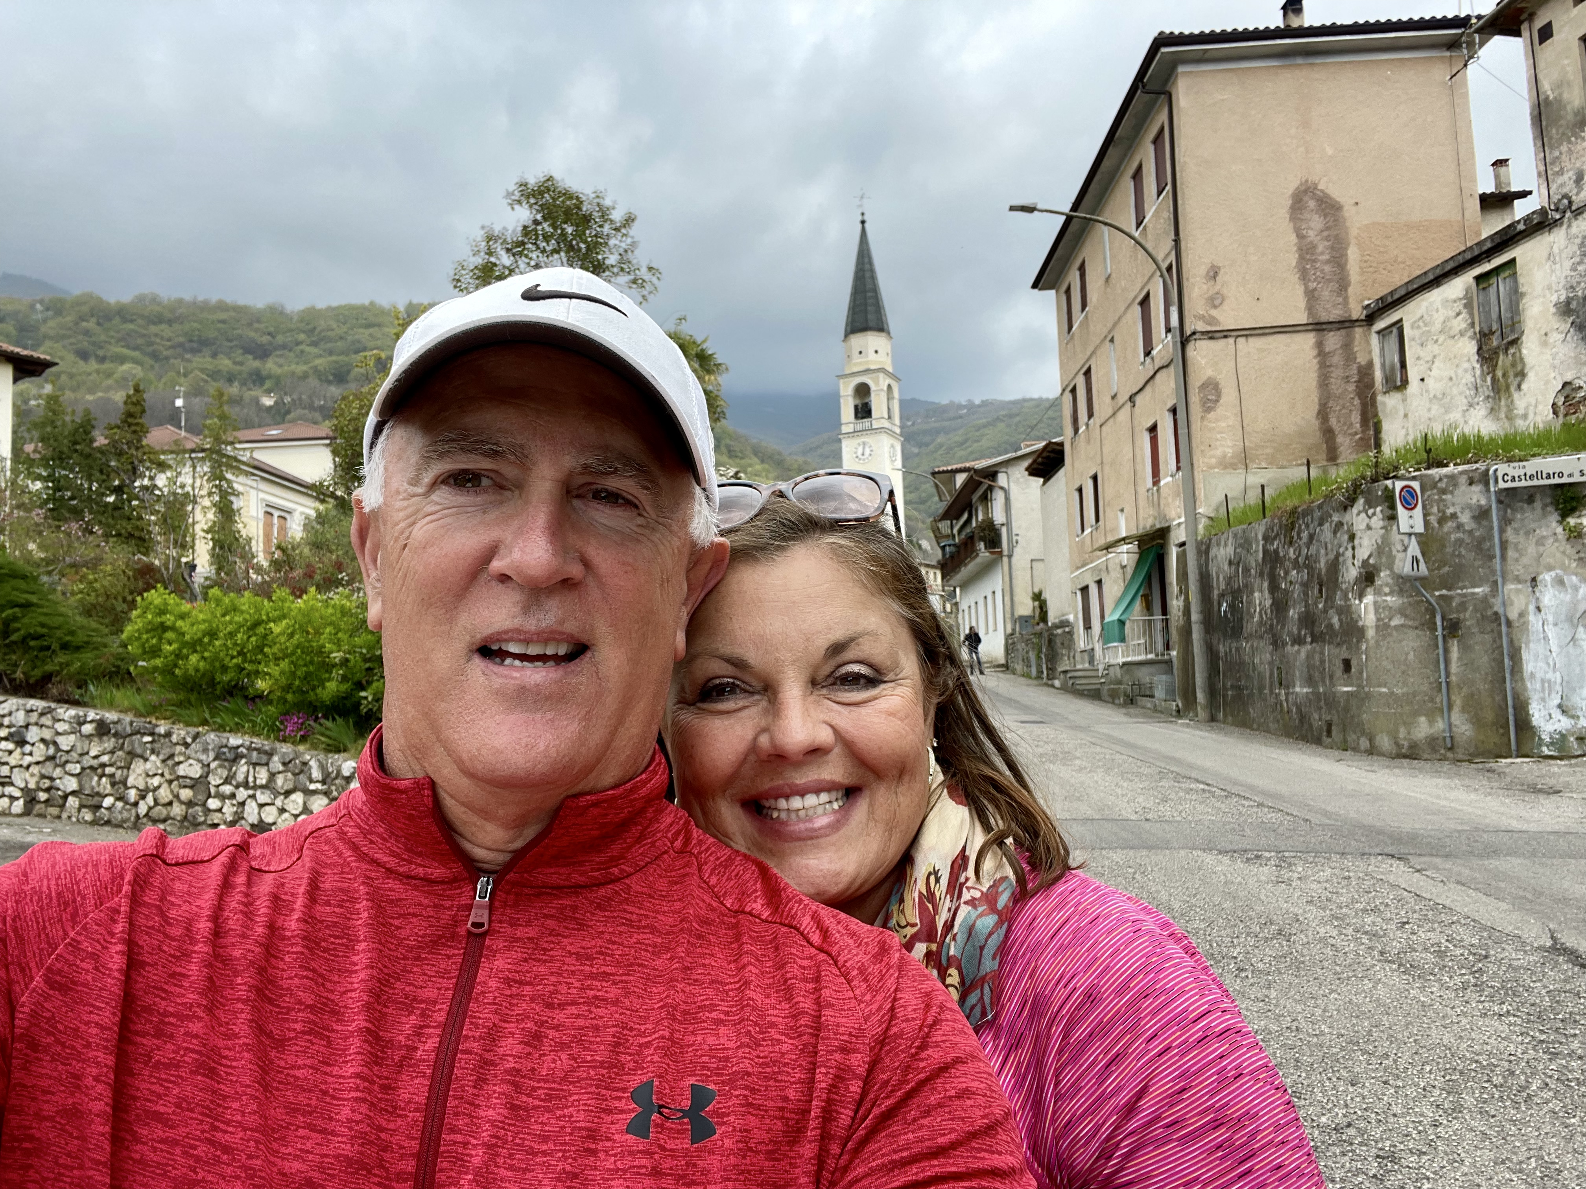

Steve & Connie on Roma Street in Calvene, Italy